Springboot Integration with Kafka

Create a springboot project with web, spring kafka, dev tool dependency.

Create class for sending messages

Create a controller through we can call this send method to send messages.

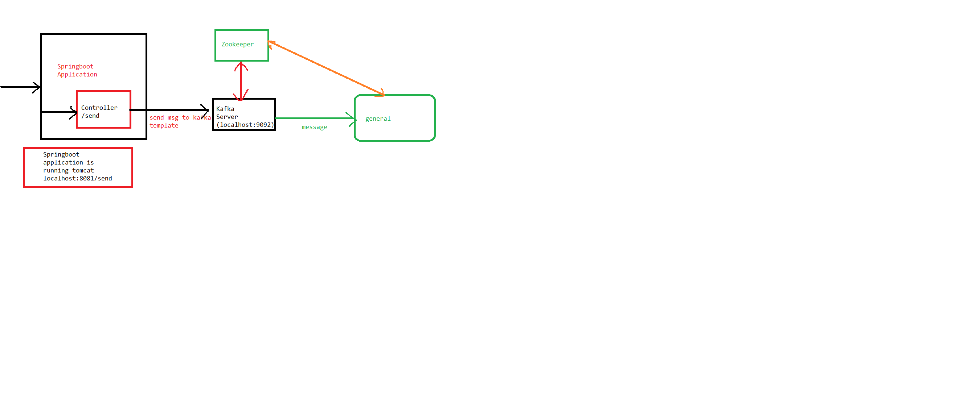

Put all services in service package and controllers in controllers’ package.

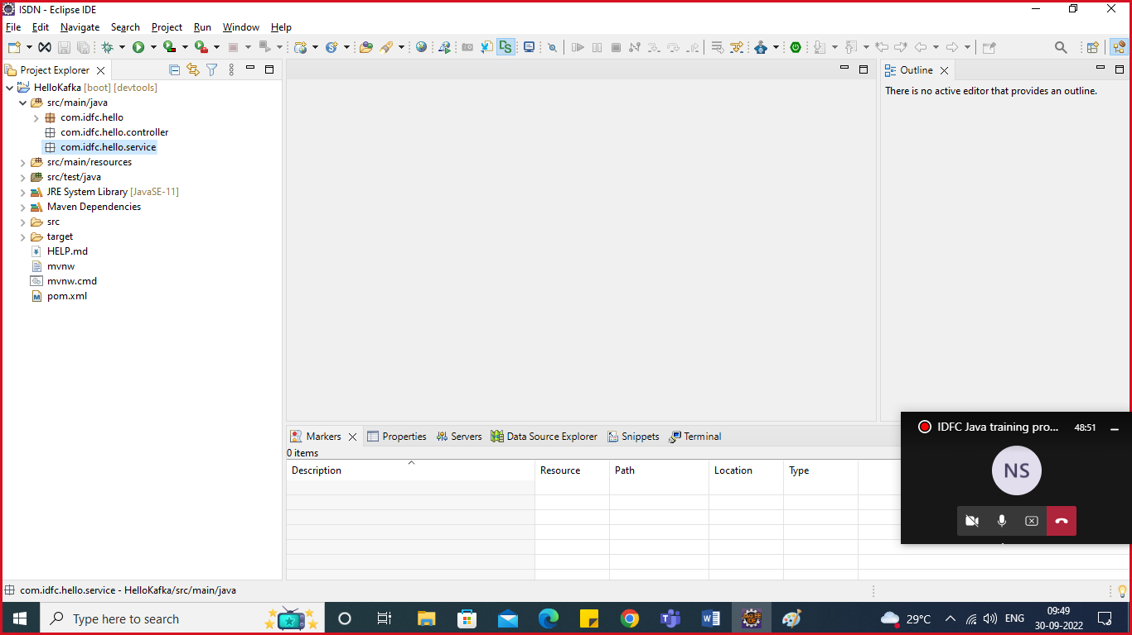

Create Service KafkaSender

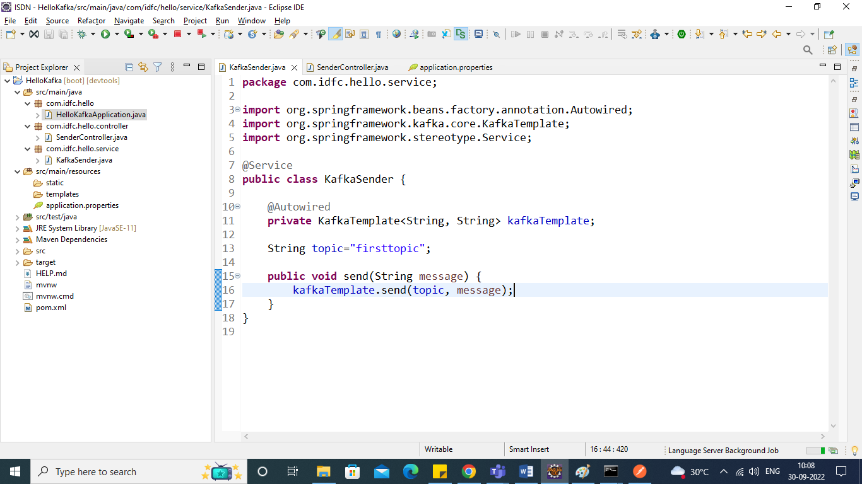

Create Controller Named SenderController (RestController)

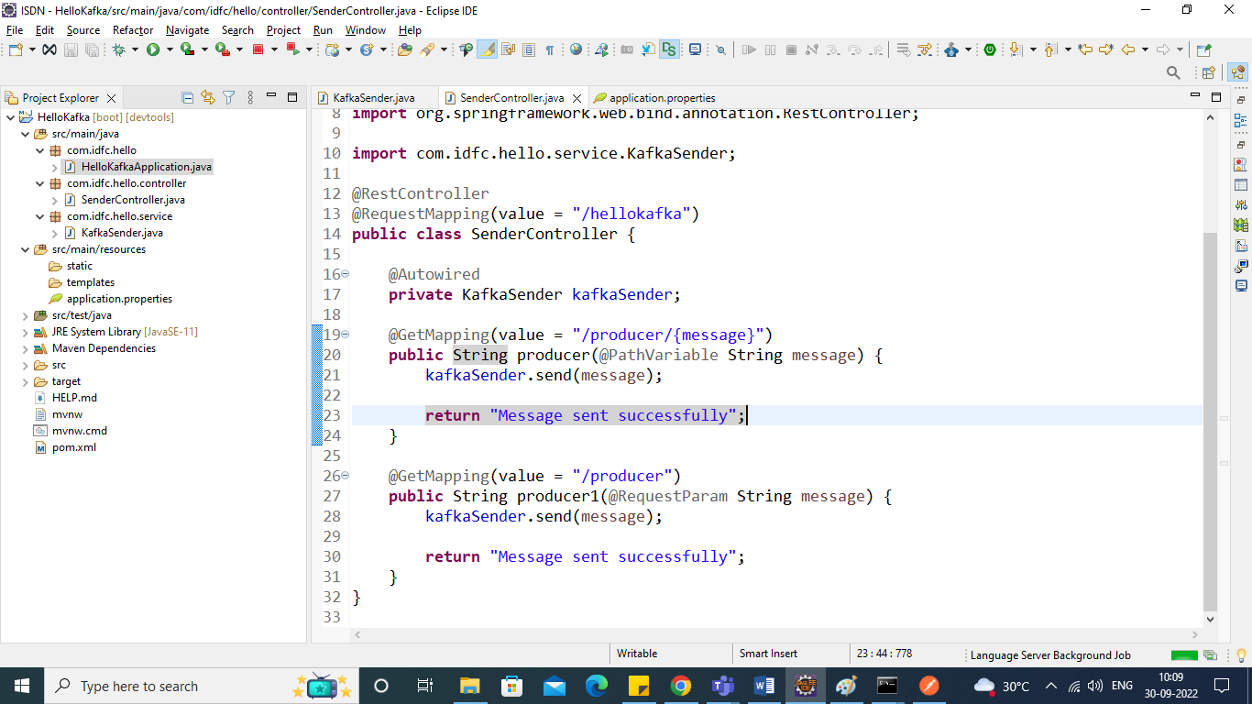

Run your app on port 8081 change application.properties file

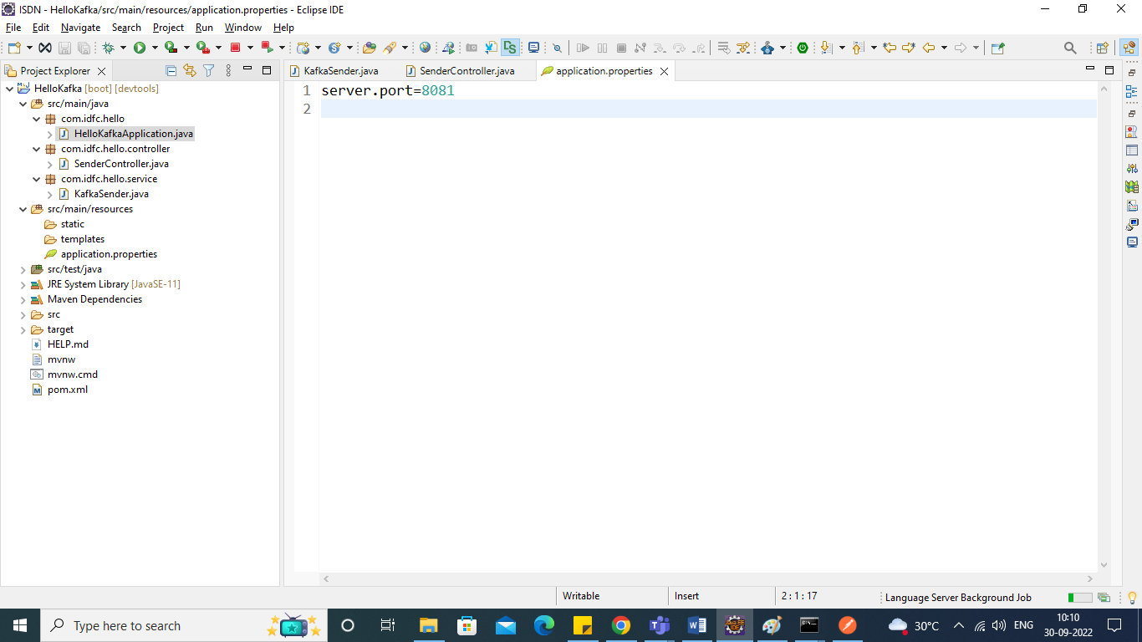

Run application and check the same through postman

Check for Request Param

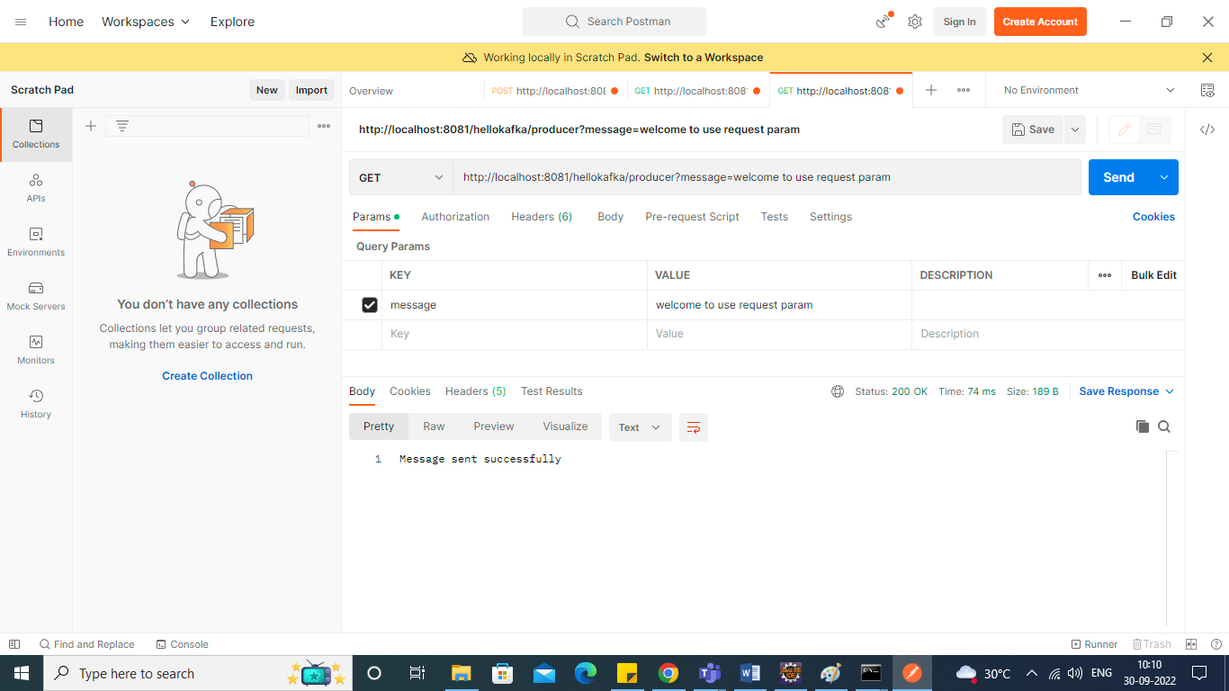

To see the messaged in consumer.

Start zoopeeker first then kafka server

Then check the consumer messages.

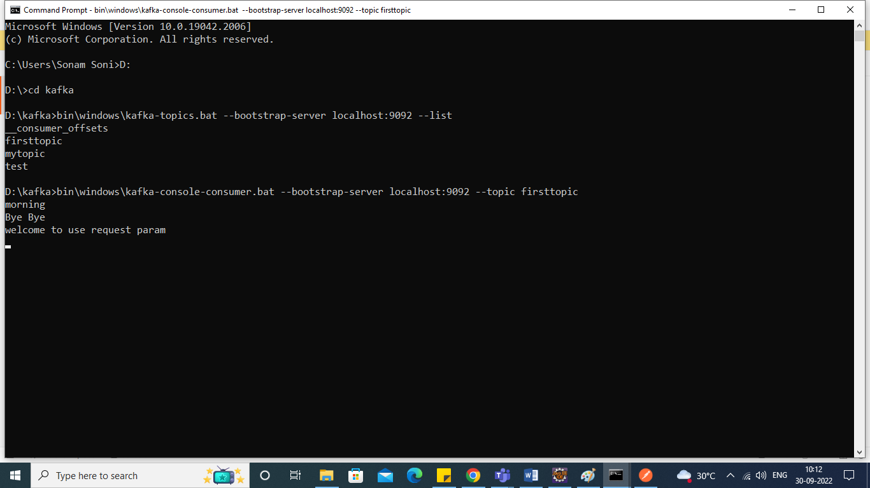

Every time when you hit the url consumer consumes the message.

To Check the path Variable.

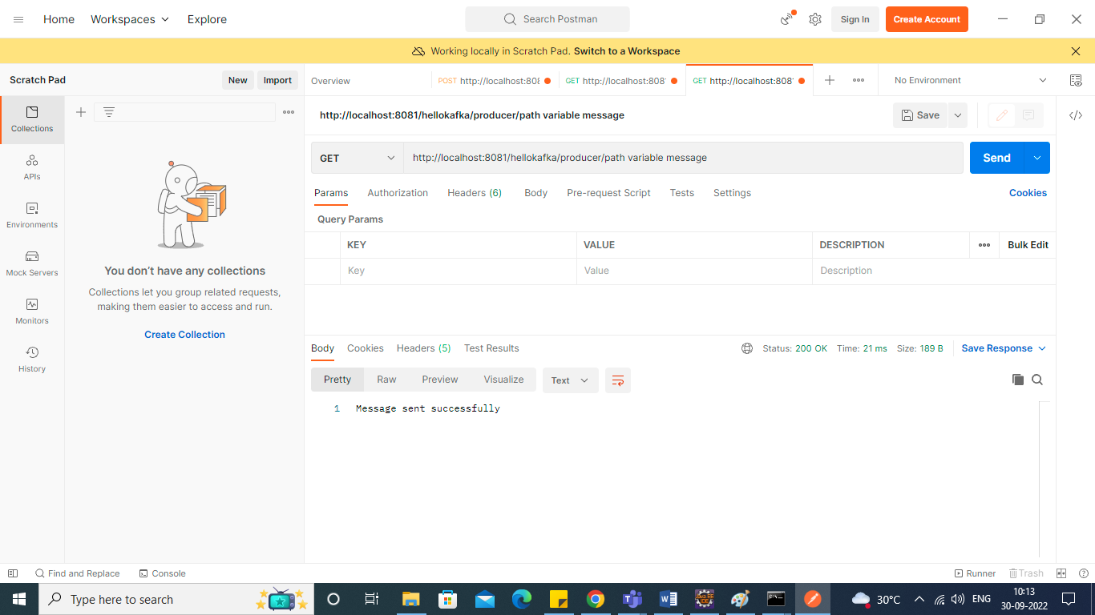

Check consumer console as well.

